8. IPv4_Addressing_Part2

Maximum Hosts Per Network
To calculate the maximum number of usable hosts in a network:
- Formula: 2^N - 2, where N = number of host bits
(Subtracting 2 accounts for the Network Address and Broadcast Address, which are reserved.)

Class C Network
- Example: 192.168.1.0/24
  - Host portion: 8 bits → 28=2562^8 = 25628=256
  - Usable hosts: 256−2=254256 - 2 = 254256−2=254

Class B Network
- Example: 172.16.0.0/16
  - Host portion: 16 bits → 216=65,5362^{16} = 65,536216=65,536
  - Usable hosts: 65,536−2=65,53465,536 - 2 = 65,53465,536−2=65,534

Class A Network
- Example: 10.0.0.0/8
  - Host portion: 24 bits → 224=16,777,2162^{24} = 16,777,216224=16,777,216
  - Usable hosts: 16,777,216−2=16,777,21416,777,216 - 2 = 16,777,21416,777,216−2=16,777,214

First and Last Usable Addresses
For any network:
- First Usable Address: Network Address + 1
- Last Usable Address: Broadcast Address - 1

Class C Network
- Network Address: 192.168.1.0/24
  - First: 192.168.1.1
  - Last: 192.168.1.254

Class B Network
- Network Address: 172.16.0.0/16
  - First: 172.16.0.1
  - Last: 172.16.255.254

Class A Network
- Network Address: 10.0.0.0/8
  - First: 10.0.0.1
  - Last: 10.255.255.254

Cisco CLI Device Configuration

Basic Commands
Enable Privileged EXEC Mode:
R1> enable

View Interface Summary:
R1# show ip interface brief 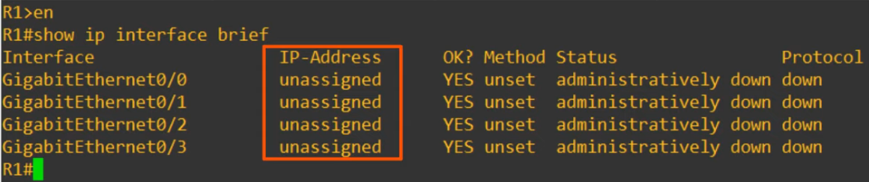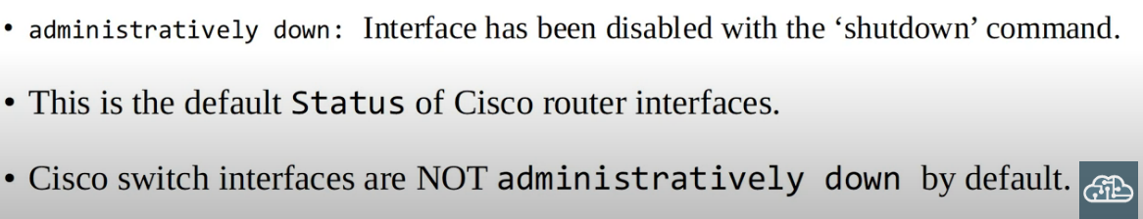
Status -> Layer 1 status
Protocol -> Layer 2 status

Interface Configuration Mode
Enter Configuration Mode:
R1# conf t

Select Interface:
R1(config)# interface gigabitethernet 0/0
Shortcut: g0/0
Assign IP Address and Subnet Mask:
R1(config-if)# ip address 10.255.255.254 255.0.0.0

Enable the Interface:
R1(config-if)# no shutdown
- Confirmation: Look for messages indicating Status: Up and Protocol: Up.
Verify Configuration (Privileged EXEC Command):
R1(config-if)# do show ip interface brief

Descriptions for Interfaces
Add a description to an interface for clarity:
R1(config)# int g0/0
R1(config)# description ## to SW1 ##

Result in the interface table:
Interface Description
Gi0/0 ## to SW1 ##

Additional Useful Commands
View Detailed Interface Information:
R1# show interfaces <interface name>
- Displays Layer 1, Layer 2, and some Layer 3 details (e.g., MAC Address, IP Address).
Show Descriptions for All Interfaces:
R1# show interfaces description

